**Window properties**

1. **Window.open(“URL”, “Name or Attribute”, “Specification”, “History place”)**

This function is used to open a new window. **Where:**

1. **URL** (Optional)**:** the path of the new window [default is a white empty page].
2. **Name or Attribute** (Optional)**:**
   1. **Name:** is a specific name for this window used to call it. (like: ID)
   2. **Attribute:** is the target of the window. (_blank (default), _self, _parent, _top)
3. **Specification** (Optional)**:** are the page properties. Like: (Width = 500, Height = 200, left = 100, top = 100, status = no, menubar = yes).

[Default unit is pixel so you mustn’t write it]; status and menubar properties take **Boolean** values [“**yes**” or “**no**”]. If you don’t determine specification the new window will take the same properties of the main (parent) one.

**History place** (Optional)**:** is used to save visited data in history to be able to back to it again by using 🡪 🡨 on the top window, it take a **Boolean** values [“**true**” or “**false**”]

**Note:** Those settings were **made by JS** so you can’t modify it from the window setting (three top points⁞), you can **modify it by JS**. [What made by JS modified by JS]

**Example:**

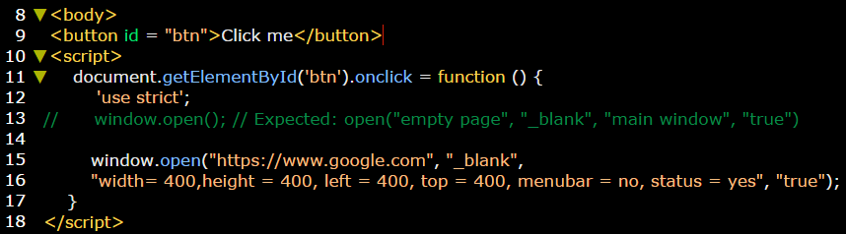

1. **Window.close ()**

This function is used to close the main (parent) window.

**Example:**

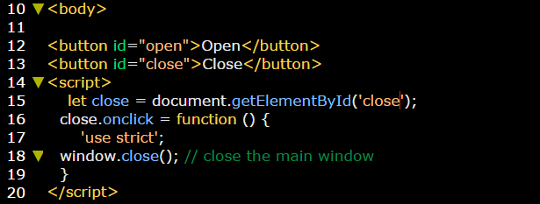

1. **Window.focus ()**

This function is used to focus the opened (child) window.

**Example:**

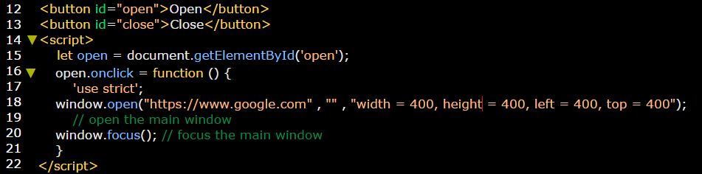

1. **Window.stop()**

This function is used to stop loading the window.

**Example:**

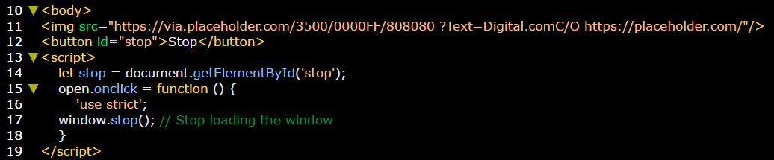

1. **Window.scrollBy(x,y)**

This function is used to determine specific number of px to scroll along all the page. We can say that function makes “**stepping scroll bar”**.

**Example**:

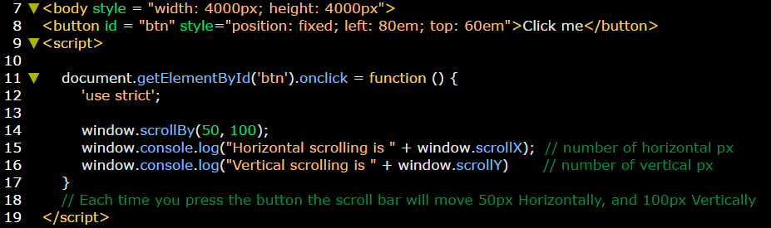

1. **Window.scrollTo (x,y)**

This function is used to determine specific number of px to Jump to it from any position in one step only. We can say that function makes “**jumping scroll bar”**.

**Example:** the scroll bar will jumps from its current position to (0, 0) in **one step**.

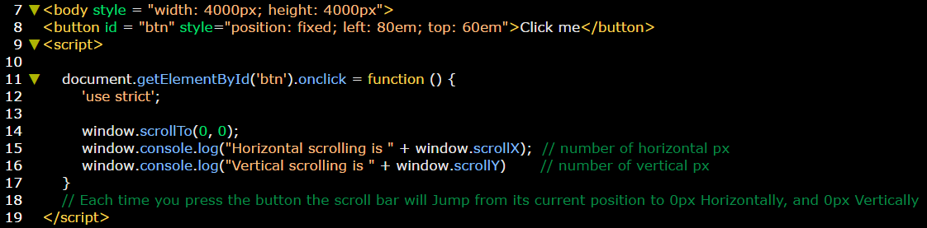

1. **Window dimensions**

There are some properties used to get window dimensions, these properties are:

1. **innerHeight:** get the inner height of the window (**changeable** height depending on window size).
2. **outerHeight:** get the outer height of the window (**fixed** Height).
3. **innerWidth:** get the inner height of the window (**changeable** width depending on window size).
4. **outerWidth:** get the inner height of the window (**fixed** width).

**Illustration:**

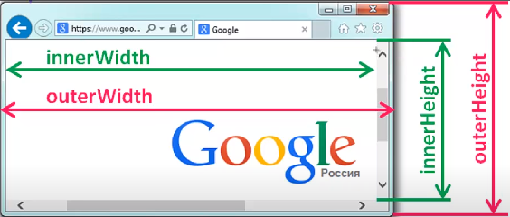

**Example:**

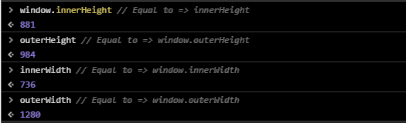

1. **Window.pageXOffset = window.scrollX**

This method is used to get the amount of horizontal scroll (X) in pixels. According to this value you can use other statements like (if statement) to apply some ideas.

**Example:**

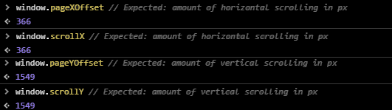

1. **Window.pageYOffset = window.scrollY**

This method is used to get the amount of vertical scroll (Y) in pixels. According to this value you can use other statements like (if statement) to apply some ideas.

**Example:**



**Note:** window.scrollTo and window.scrollBy both consist of two properties [window.scrollX and window.scrollY]